https://play.picoctf.org/practice/challenge/3?category=2&page=2

I tried to search la cifra de to see what is it meaning and saw that it is included in

the article about vigenere cipher in wikipedia

Is it possible to break vigenere without key ? The answer is yes :D

Use this magical tool : <https://www.guballa.de/vigenere-solver>

And I got something like this: 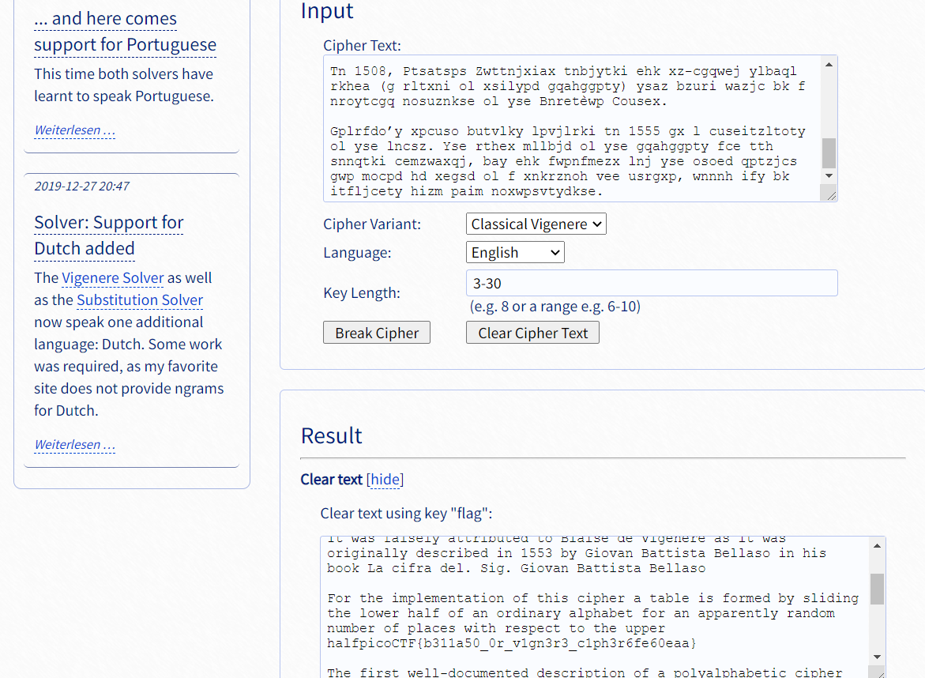

* picoCTF{b311a50_0r_v1gn3r3_c1ph3r6fe60eaa}